**PYTHON ASSIGNMENT PLOTS**

* 1. **Total sales by customer**

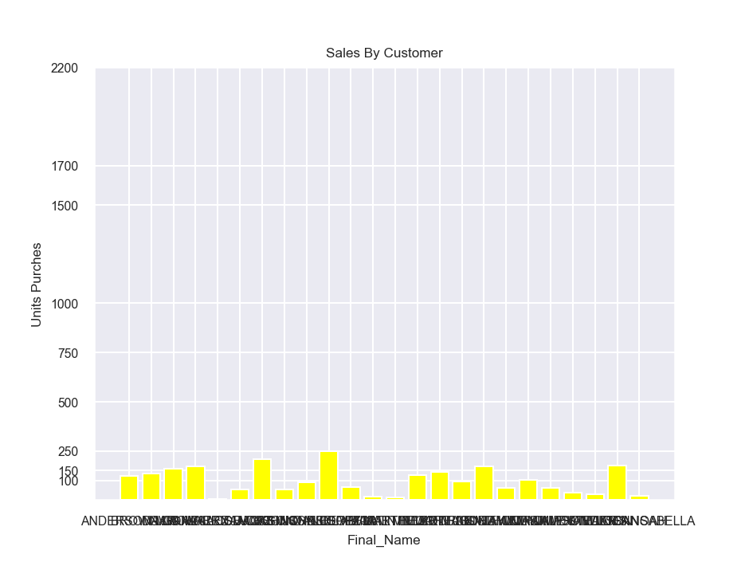

* 1. **Total sales by gender**

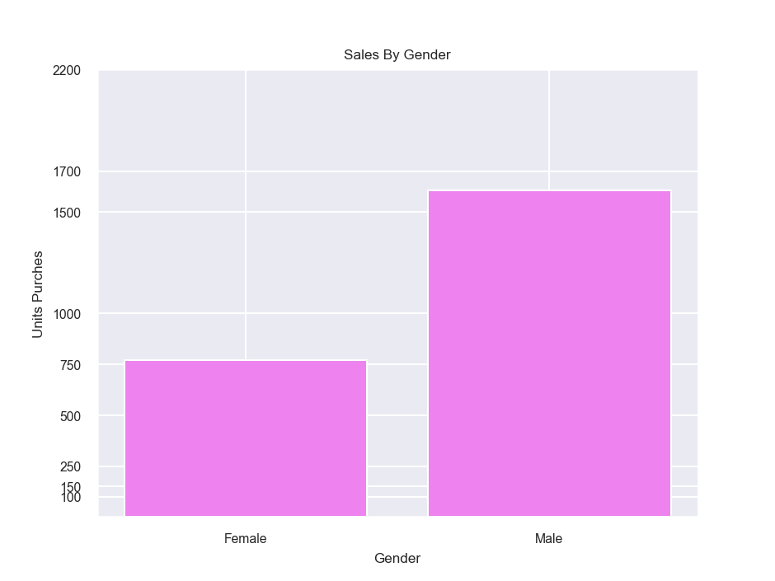

* 1. **Total sales per year**

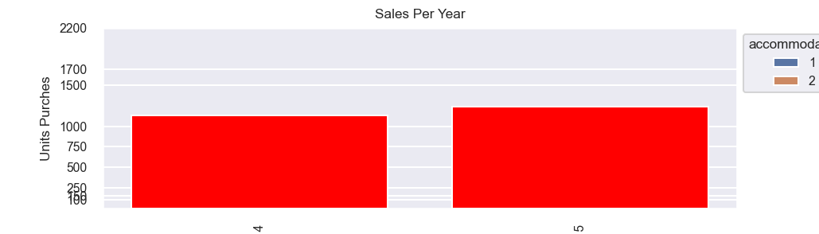

**1.6. Create age bins/groups of your choice and calculate the total sales per bin/group**

